# Practical 7 Create an HTML page with internal sheet.

<html>

<head> <title> </title>

<style>

p{

font-family:Times New Roman; font-size:100%;

font-style:normal; font-weight:lighter;

}

p.ab{

font-family:Ariel; font-size:200%;

font-style:bold; font-weight:bold;

}

p.cd{

font-family:Calibri; font-size:300%;

font-style:italic; font-weight:bolder;

}

</style>

</head>

<body>

<h3>Kaustubh Wade(160410116050)</h3>

<p>Normal Text</p>

<p class="ab">Bold Text</p>

<p class="cd">Bolder Text</p>

</body>

</html>

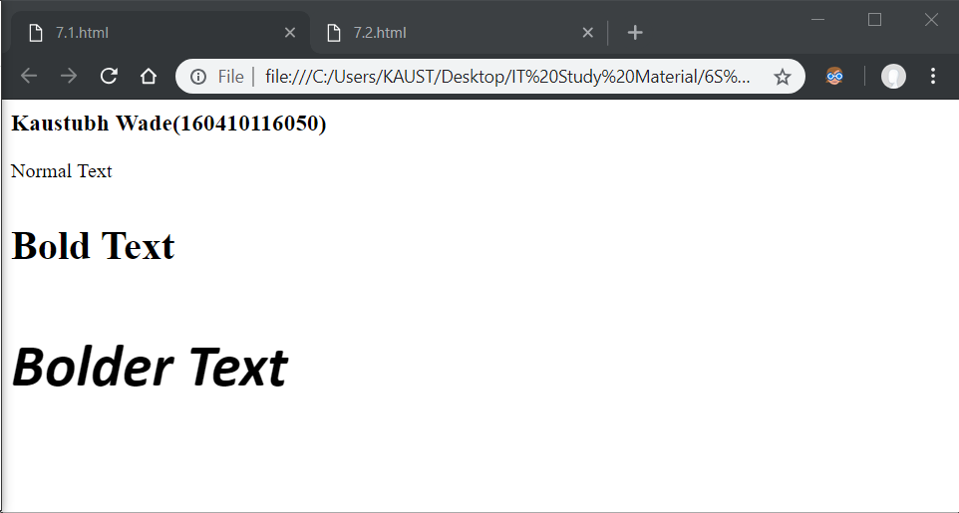

<html>

<head> <title> </title>

<style>

p{

text-align:left; text-decoration:underline; text-transform:capitalize;

}

p.ab{

text-align:right; text-decoration:line-through; text-transform:uppercase;

}

p.cd{

text-align:center; text-decoration:overline; text-transform:lowercase;

}

</style>

</head>

<body> <h3>Kaustubh Wade(160410116050)</h3>

<p>Text 1</p>

<p class="ab">Text 2</p>

<p class="cd">Text 3</p>

</body>

</html>

